Test Case: tc001_SPX_Dev5_Crear_Requisicion_Spot_Tipo_Cobro_CC
Step 1 - Enter username and password and click to button Enter : Credentials Entered
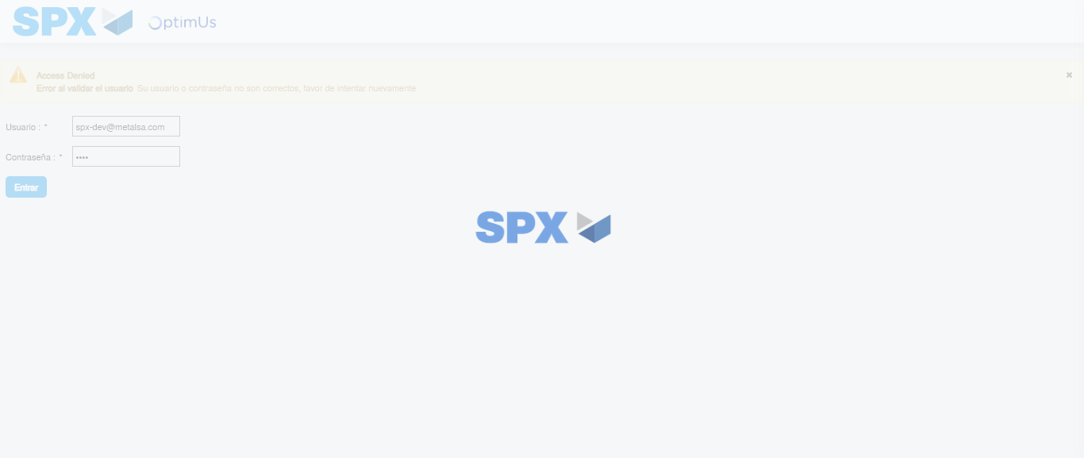Image file-name: QC_Testing-tc001_SPX_Dev5_Crear_Requisicion_Spot_Tipo_Cobro_CC-1782164852698

Step 2 - Select to UEN and Access to Spot Buy Requisitions : UEN Correctly selected and Correct access
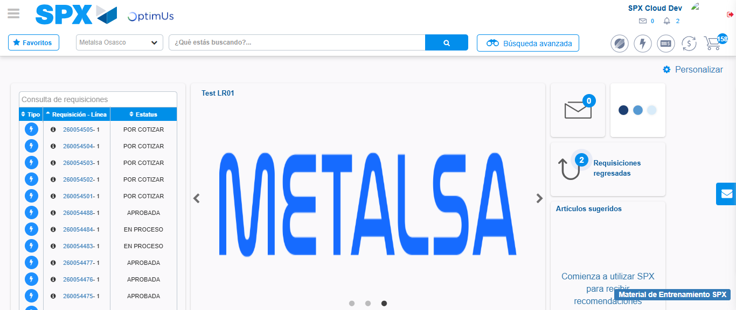Image file-name: QC_Testing-tc001_SPX_Dev5_Crear_Requisicion_Spot_Tipo_Cobro_CC-1782164879694

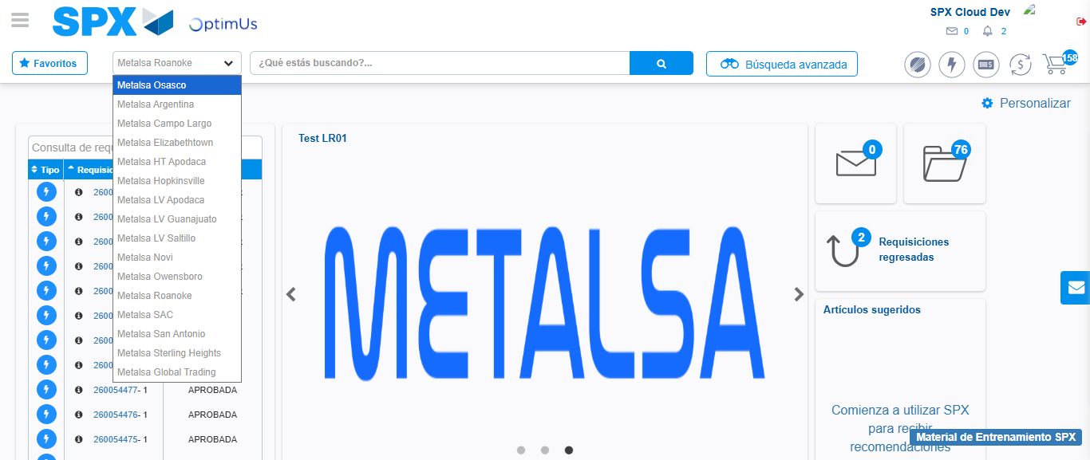Image file-name: QC_Testing-tc001_SPX_Dev5_Crear_Requisicion_Spot_Tipo_Cobro_CC-1782164882194

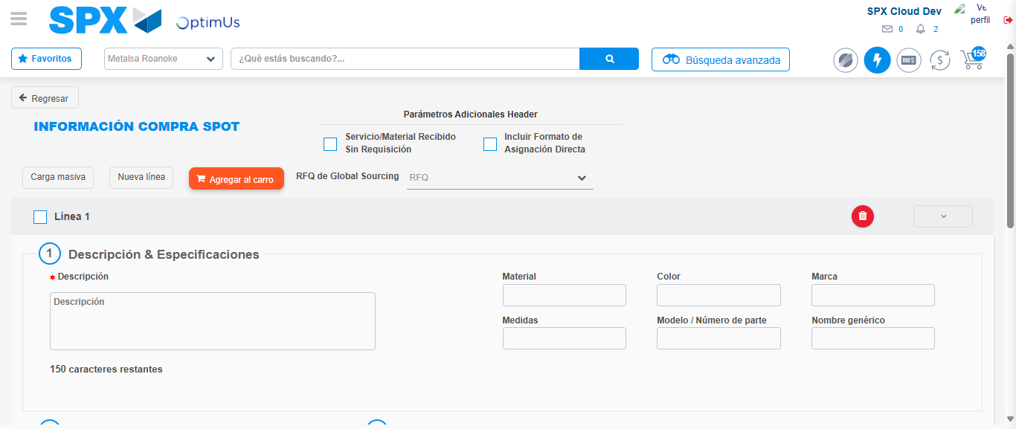Image file-name: QC_Testing-tc001_SPX_Dev5_Crear_Requisicion_Spot_Tipo_Cobro_CC-1782164905269

Step 3 - Data Capture Spot Buy Requisition : Data captured correctly
Image file-name: QC_Testing-tc001_SPX_Dev5_Crear_Requisicion_Spot_Tipo_Cobro_CC-1782164905535

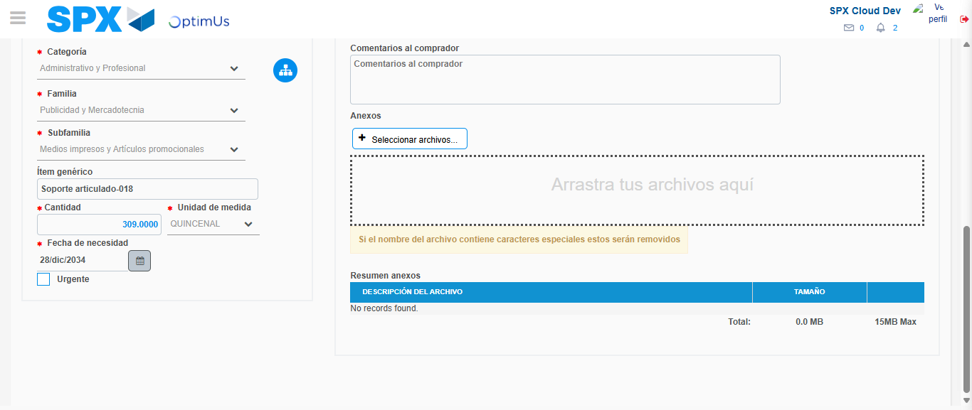Image file-name: QC_Testing-tc001_SPX_Dev5_Crear_Requisicion_Spot_Tipo_Cobro_CC-1782164915732

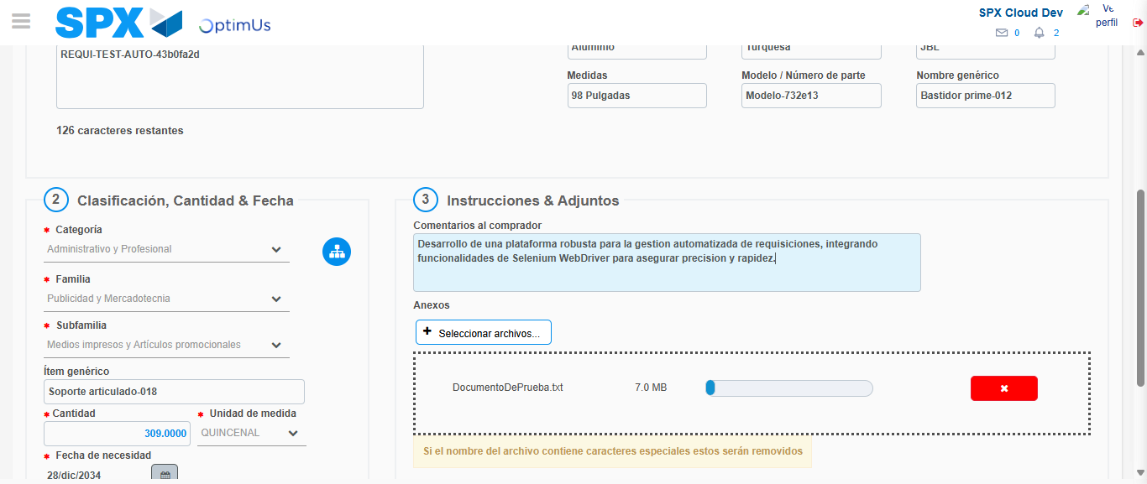Image file-name: QC_Testing-tc001_SPX_Dev5_Crear_Requisicion_Spot_Tipo_Cobro_CC-1782164916526

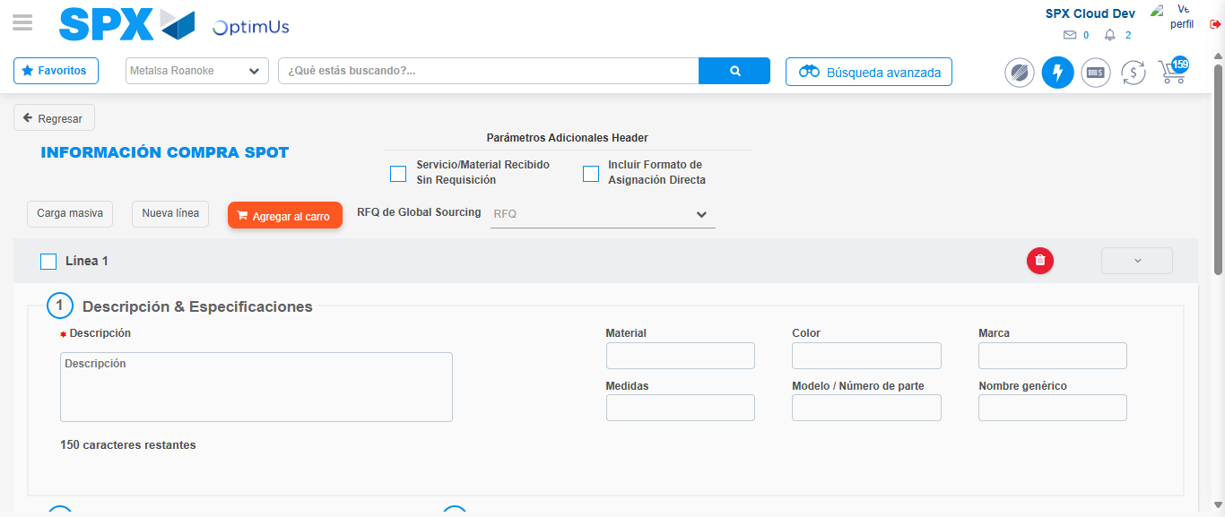Image file-name: QC_Testing-tc001_SPX_Dev5_Crear_Requisicion_Spot_Tipo_Cobro_CC-1782164919486

Step 4 - Select to Requisition : Requisition Correctly selected
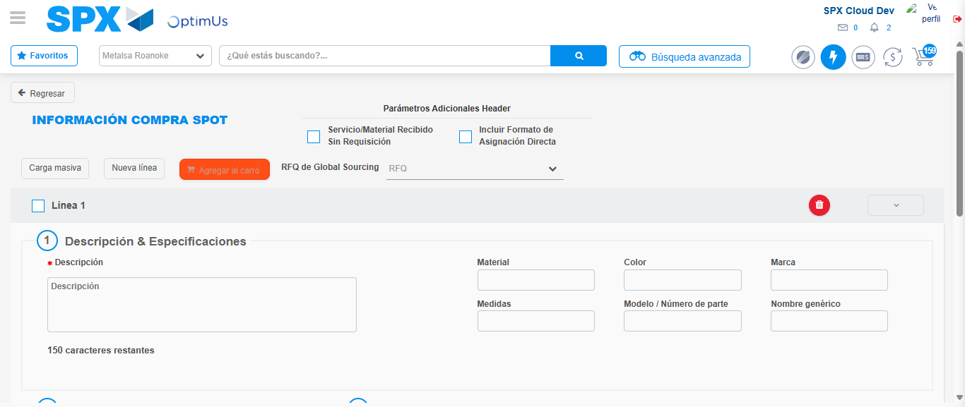Image file-name: QC_Testing-tc001_SPX_Dev5_Crear_Requisicion_Spot_Tipo_Cobro_CC-1782164919692

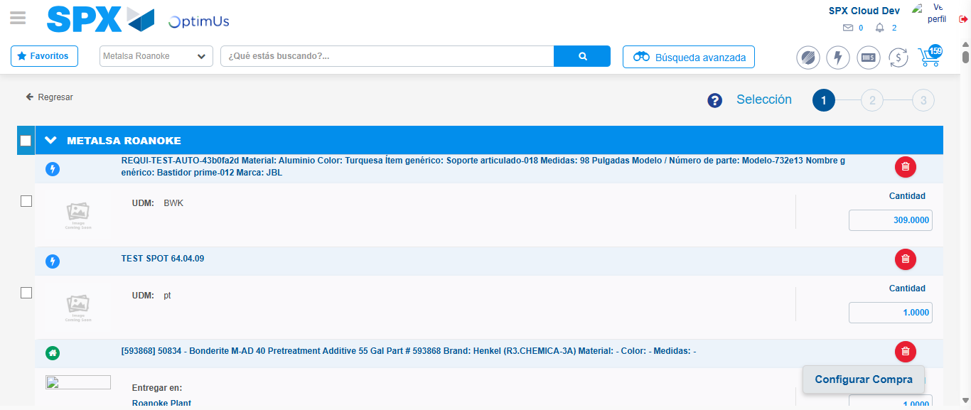Image file-name: QC_Testing-tc001_SPX_Dev5_Crear_Requisicion_Spot_Tipo_Cobro_CC-1782164931415

Image file-name: QC_Testing-tc001_SPX_Dev5_Crear_Requisicion_Spot_Tipo_Cobro_CC-1782164931652

Image file-name: QC_Testing-tc001_SPX_Dev5_Crear_Requisicion_Spot_Tipo_Cobro_CC-1782164931886

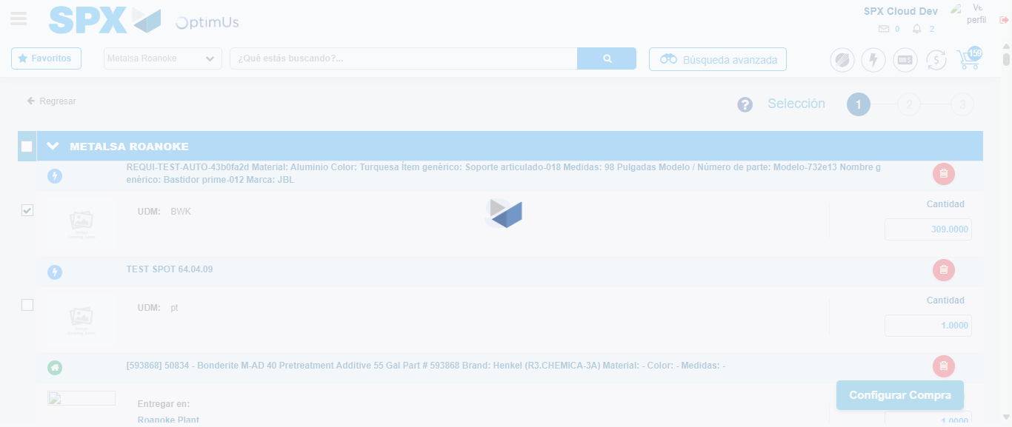Image file-name: QC_Testing-tc001_SPX_Dev5_Crear_Requisicion_Spot_Tipo_Cobro_CC-1782164933820

Step 5 - Select Type Account For Requisition : Type Account Correctly selected
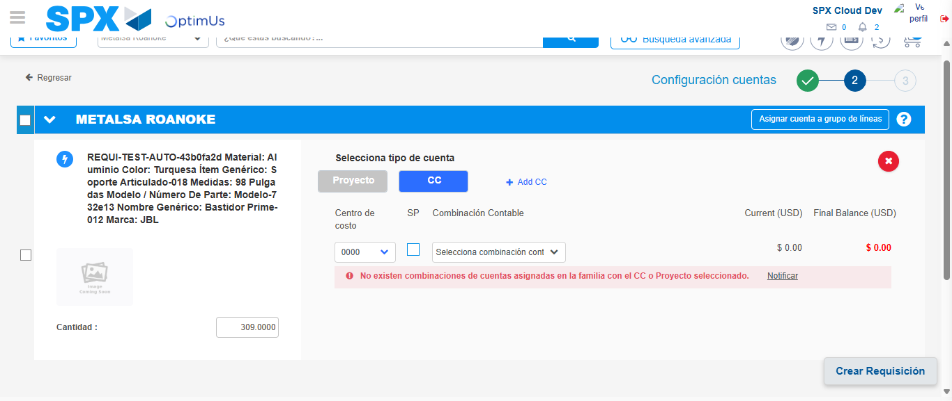Image file-name: QC_Testing-tc001_SPX_Dev5_Crear_Requisicion_Spot_Tipo_Cobro_CC-1782164948024

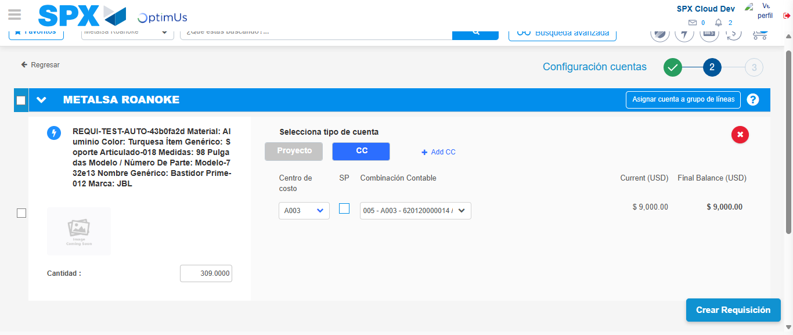Image file-name: QC_Testing-tc001_SPX_Dev5_Crear_Requisicion_Spot_Tipo_Cobro_CC-1782164952829

Image file-name: QC_Testing-tc001_SPX_Dev5_Crear_Requisicion_Spot_Tipo_Cobro_CC-1782164952958

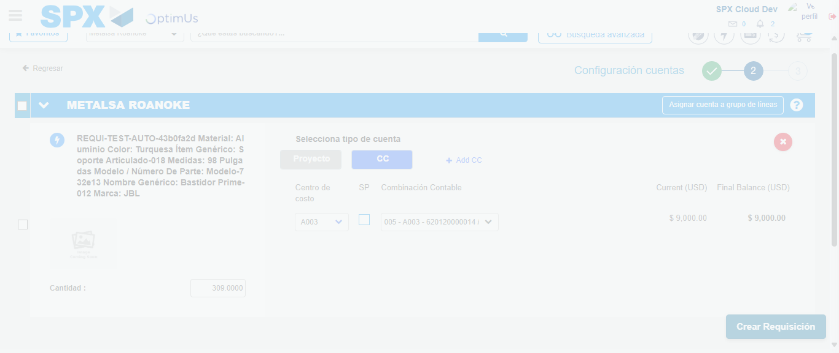Image file-name: QC_Testing-tc001_SPX_Dev5_Crear_Requisicion_Spot_Tipo_Cobro_CC-1782164953336

Step 6 - Accept to Requisition : Requisition Accepted
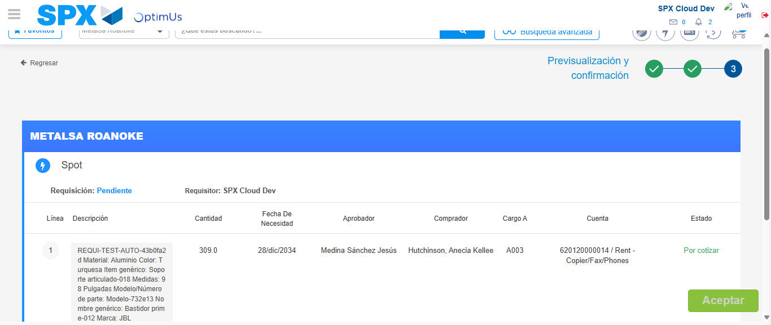Image file-name: QC_Testing-tc001_SPX_Dev5_Crear_Requisicion_Spot_Tipo_Cobro_CC-1782164954122

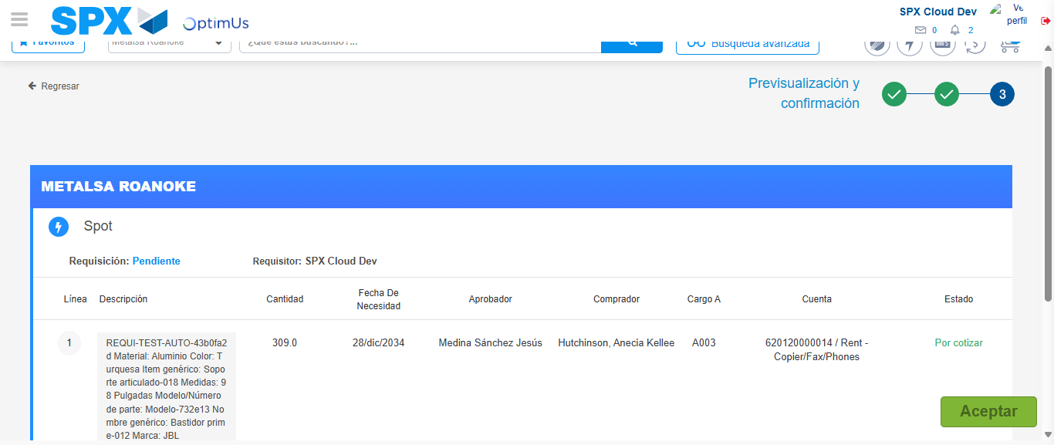Image file-name: QC_Testing-tc001_SPX_Dev5_Crear_Requisicion_Spot_Tipo_Cobro_CC-1782164954405

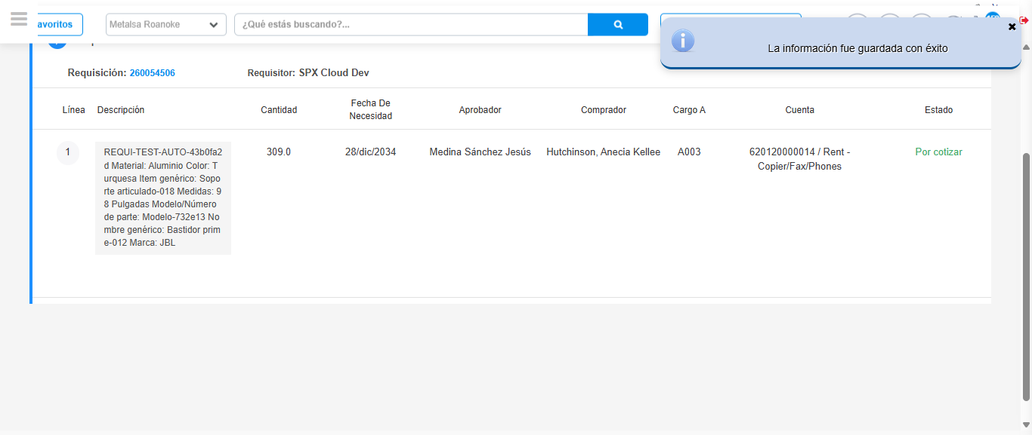Image file-name: QC_Testing-tc001_SPX_Dev5_Crear_Requisicion_Spot_Tipo_Cobro_CC-1782164957393

Step 7 - Return to Main Page SPX : Return to Main Page SPX
Image file-name: QC_Testing-tc001_SPX_Dev5_Crear_Requisicion_Spot_Tipo_Cobro_CC-1782164879694

Image file-name: QC_Testing-tc001_SPX_Dev5_Crear_Requisicion_Spot_Tipo_Cobro_CC-1782164882194

Image file-name: QC_Testing-tc001_SPX_Dev5_Crear_Requisicion_Spot_Tipo_Cobro_CC-1782164905269

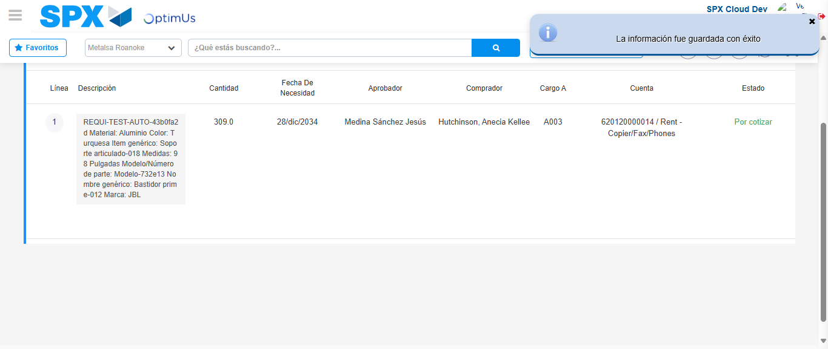Image file-name: QC_Testing-tc001_SPX_Dev5_Crear_Requisicion_Spot_Tipo_Cobro_CC-1782164959625

Image file-name: QC_Testing-tc001_SPX_Dev5_Crear_Requisicion_Spot_Tipo_Cobro_CC-1782164959779

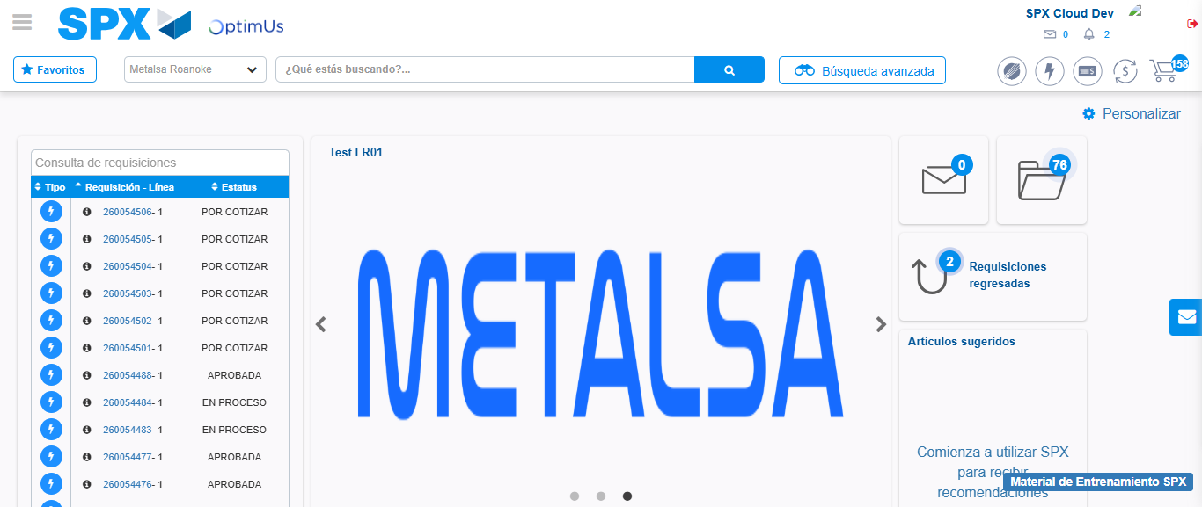Image file-name: QC_Testing-tc001_SPX_Dev5_Crear_Requisicion_Spot_Tipo_Cobro_CC-1782164980842

Step 8 - Log Out : Log Out SPX
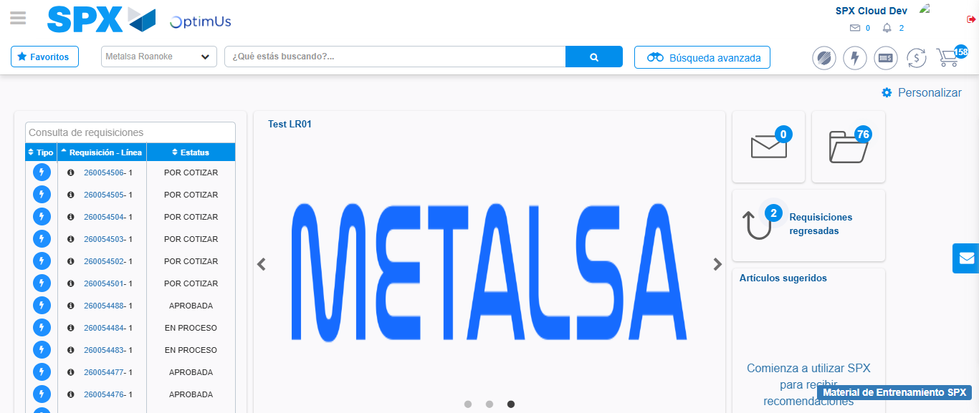Image file-name: QC_Testing-tc001_SPX_Dev5_Crear_Requisicion_Spot_Tipo_Cobro_CC-1782164981104

